**Assignment 2 – Self Guided Tutorial**

**Reflection**

During learning how to create an animation in menu bar I got an insight for the Figma tool and other things to get hands on it. It was a great learning experience for me as I have never worked on it before. I faced lots of challenges while creating this animation but finally was able to finish it by following the tutorial which was well explained.

Firstly, designing the menu items in Figma was straight forward, allowing to create seamless visualization of menu bar. Organizing layers according to the frame and then creating one single component for all the frames as one component. We can easily define the interaction with different frames and animation during the interaction. The smart animate feature enables us to create animation seamlessly linking various frames and creating fluid like animation.

However, one challenge which I remember was to find the icon Hub to add icons for the menu bar at first, I was not able to find it but after that I did some research how we can enable it when we are using the Figma for the first time. The second challenge was to give it a shape like valley and adjusting it as same for all the other icons as well. Maintaining same size for the icons was also a bit challenging. To add animation which looks smooth and creative I tried a lot for this and finally was able to make it as it was in the tutorial.

One important insight I gained during this was to give more importance to user experience and work on it until it satisfies the user needs. The seamless animation is what every user likes while using website or application in their device. It reinforced my understanding regarding the impact of visual elements on users' perception.

In future projects I will focus more on user interaction and animation effect. More experimenting with the gradian styles, icons, exploring more about animations to create a dynamic and engaging menu. Additionally, I would prioritize the user testing and gather more feedback on animations that user would more prefer, aiming for continuous improvement on the animation for application designs.

**Link to the Tutorial**: [Menu Animation in Figma](https://www.youtube.com/watch?v=P8O78APM17c)

[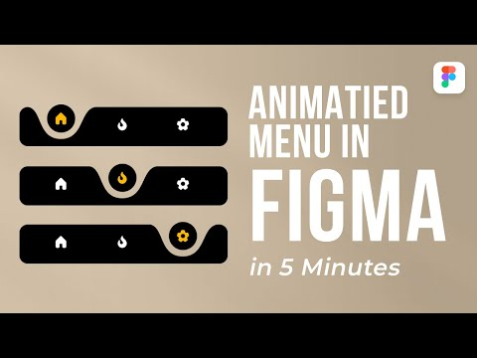](https://www.youtube.com/watch?v=P8O78APM17c)

**Link to my Figma result after implementing the tutorial**:

https://www.figma.com/file/EmpMK4iX5vs4OIHYWG93II/AnimatedMenu

**Menu animation in Figma steps**

To create menu animation in Figma involves designing the elements of menu and adding the animation to the user action. Here are the steps which I followed to create a small menu animation in Figma:

* **Open Figma / Create new project**: Open Figma and get logged in into Figma using your credentials. Then click on new design on the right top corner.

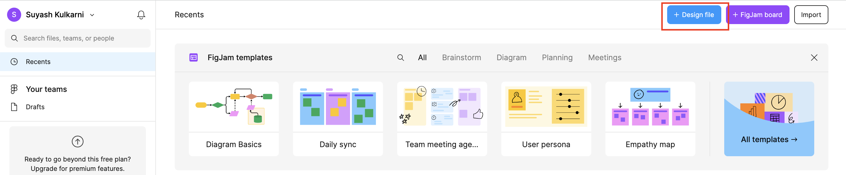

* **Add shapes for menu bar**:
  + Go the shapes menu add a rectangle shape from there. Update the border radius and colour to black.
  + Also add a circle from the shapes menu and place it over rectangle.
  + Click on the circle and move the below circles curve inside to give it a cone shape. Change the colour same a background colour.
  + Again, add the circle and place it in the curve that we made using the circle.

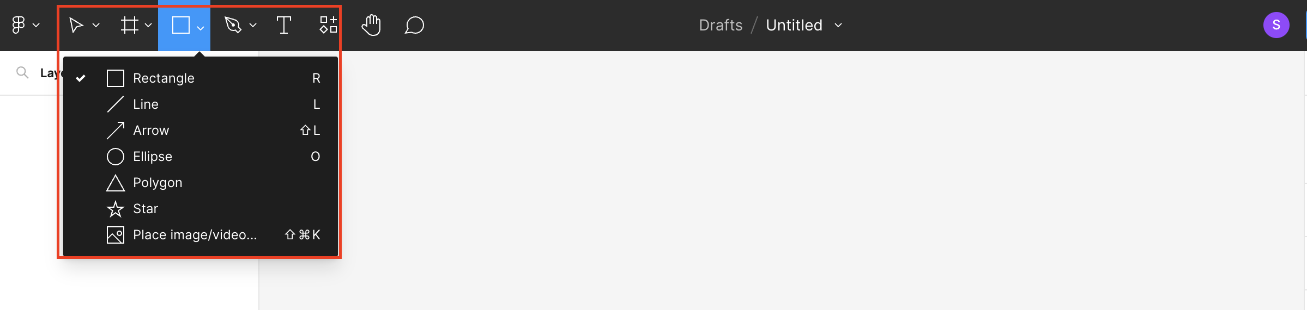

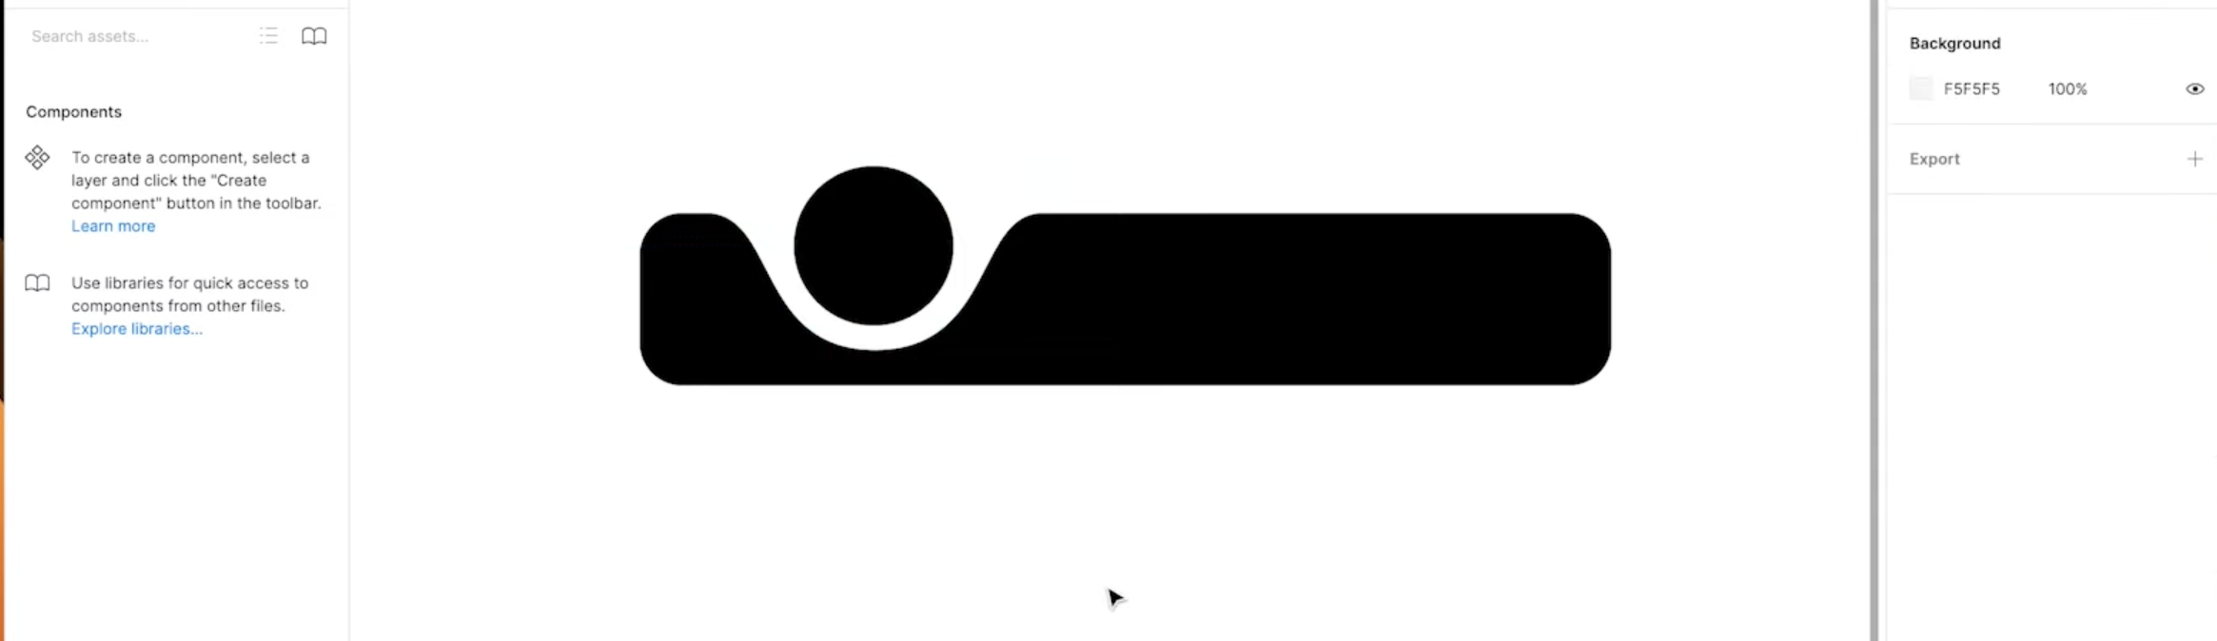

* + It will look like this.
* **Add icons for menu**:
  + We need three icons for our menu animation.
  + Open icon Duck and search for home, fire and settings icon.
  + Change the icon colour to white.
  + Place the icons at same level and with the same size and at the same distance.
  + Change the position for home icon place it into the circle that we have added and change the colour to orange.

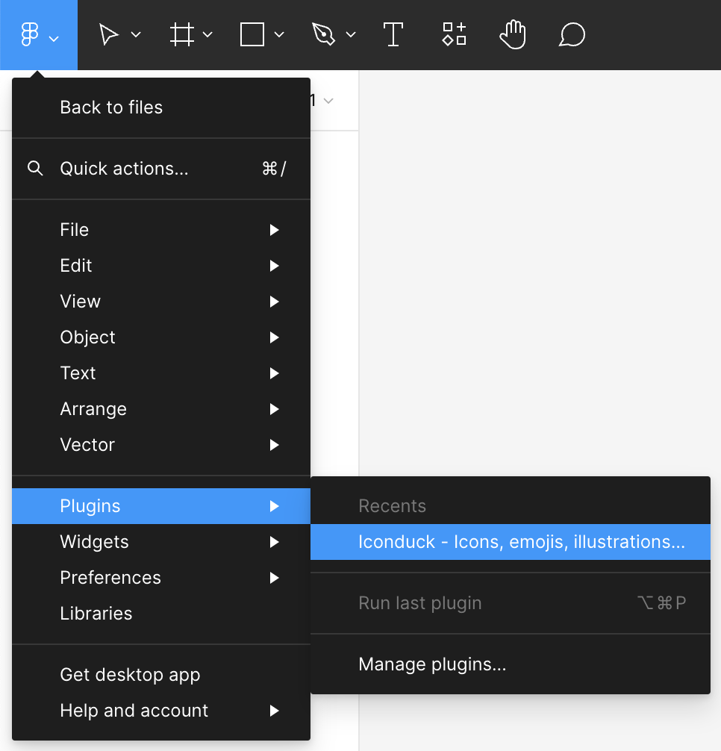

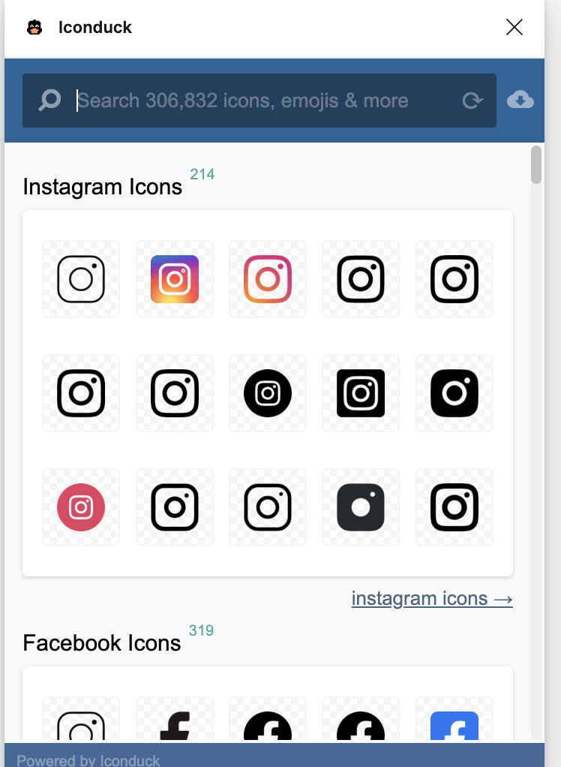

* + Search icons in this panel and click on them to add it to your screen.
* **Create Different frames**:
  + Now we need to create the same frame for settings icon as well as fire icon.
  + Follow the same steps and change the icons position in the circle for the frames respectively.

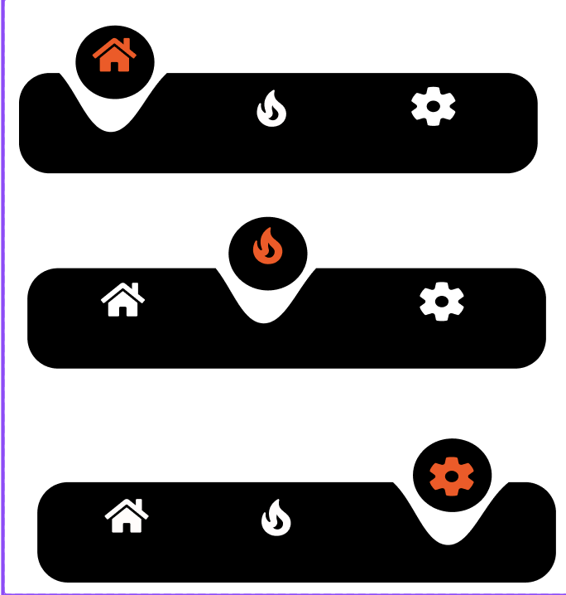

* + It will look this way after you follow all the steps.
* **Create a component**:
  + Select all the frames and in the top of the screen you will find a diamond like icon click on that.
  + Select the option to create component set.
  + This will create a component for all your frames in one.